Signals & Communication Systems - Lab-7
Sampling of Signals
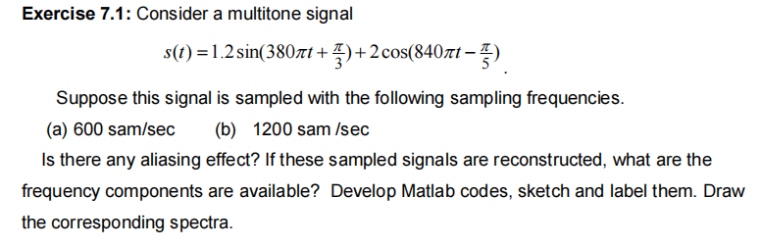
Sol:
% Part (a): Sampling Frequency 600 Hz
clear all;
close all;
% Signal parameters
f1 = 190; % Hz
f2 = 420; % Hz
fs = 600; % Hz
Ts = 1/fs;
% Time vector for continuous signal (for plotting)
t = 0:Ts/100:0.02;
s_t = 1.2*sin(2*pi*f1*t + pi/3) + 2*cos(2*pi*f2*t - pi/5);
% Discrete time vector for sampled signal
n = 0:round(0.02/Ts);
s_n = 1.2*sin(2*pi*f1*n*Ts + pi/3) + 2*cos(2*pi*f2*n*Ts - pi/5);
% Plot the original and sampled signals
figure;
plot(t, s_t, 'b', 'DisplayName', 'Original Signal');
hold on;
stem(n*Ts, s_n, 'r', 'filled', 'DisplayName', 'Sampled Signal');
grid on;
title('Original and Sampled Signals ($f_s = 600$ Hz)');
xlabel('Time (s)');
ylabel('Amplitude');
legend;
% Frequency Spectrum
N = length(s_n);
f_fft = (-N/2:N/2-1) * (fs/N);
S_n_fft = fftshift(fft(s_n));
figure;
plot(f_fft, abs(S_n_fft), 'b');
grid on;
title('Frequency Spectrum ($f_s = 600$ Hz)');
xlabel('Frequency (Hz)');
ylabel('Magnitude');
% The spectrum will show peaks at 190 Hz and 180 Hz (and their negative counterparts).
Figure:
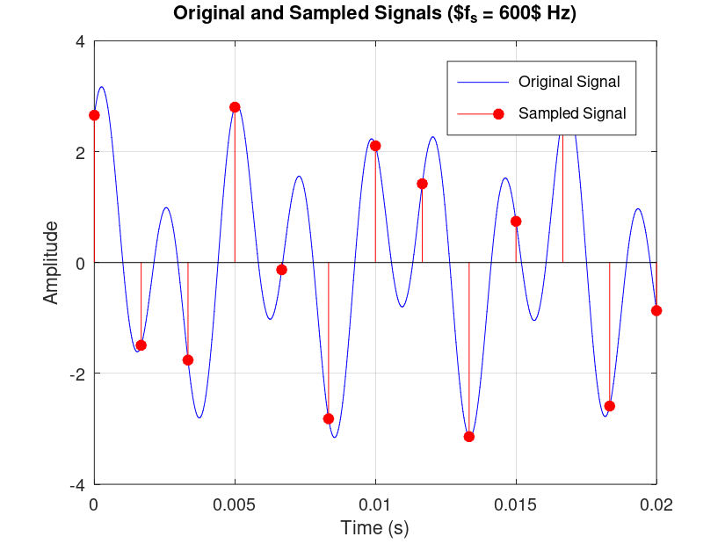
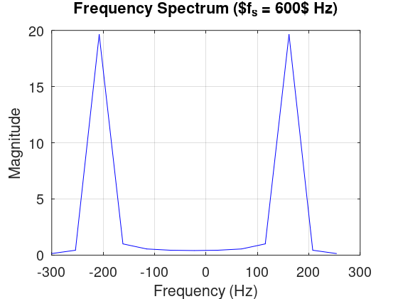
B-Sol:
% Part (b): Sampling Frequency 1200 Hz
clear all;
close all;
% Signal parameters
f1 = 190; % Hz
f2 = 420; % Hz
fs = 1200; % Hz
Ts = 1/fs;
% Time vector for continuous signal (for plotting)
t = 0:Ts/100:0.02;
s_t = 1.2*sin(2*pi*f1*t + pi/3) + 2*cos(2*pi*f2*t - pi/5);
% Discrete time vector for sampled signal
n = 0:round(0.02/Ts);
s_n = 1.2*sin(2*pi*f1*n*Ts + pi/3) + 2*cos(2*pi*f2*n*Ts - pi/5);
% Plot the original and sampled signals
figure;
plot(t, s_t, 'b', 'DisplayName', 'Original Signal');
hold on;
stem(n*Ts, s_n, 'r', 'filled', 'DisplayName', 'Sampled Signal');
grid on;
title('Original and Sampled Signals ($f_s = 1200$ Hz)');
xlabel('Time (s)');
ylabel('Amplitude');
legend;
% Frequency Spectrum
N = length(s_n);
f_fft = (-N/2:N/2-1) * (fs/N);
S_n_fft = fftshift(fft(s_n));
figure;
plot(f_fft, abs(S_n_fft), 'b');
grid on;
title('Frequency Spectrum ($f_s = 1200$ Hz)');
xlabel('Frequency (Hz)');
ylabel('Magnitude');
% The spectrum will show peaks at 190 Hz and 420 Hz (and their negative counterparts).
Figures:
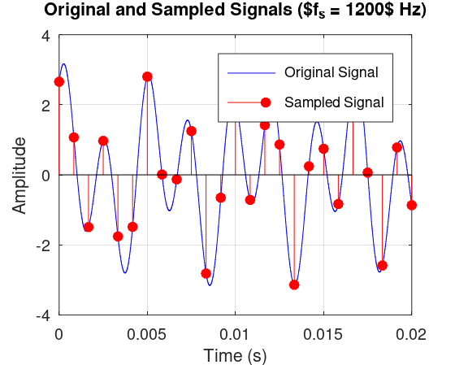
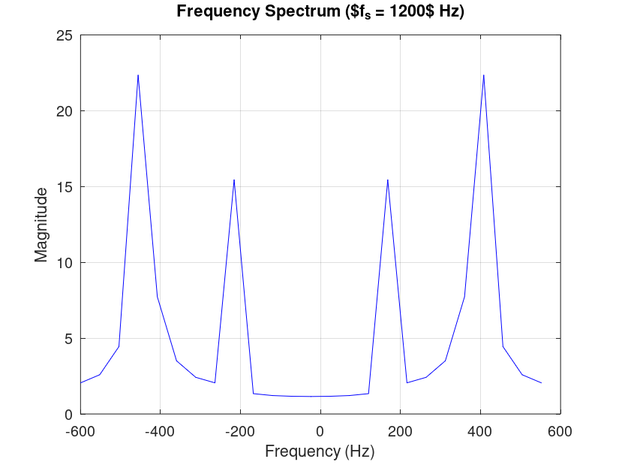

Sol:
clear; close all;
f1 = 190; f2 = 420; % Hz
fs_vals = [600, 1200]; % Sampling frequencies (Hz)
Tmax = 0.02;
for k = 1:2
fs = fs_vals(k); Ts = 1/fs;
t = 0:Ts/100:Tmax;
n = 0:round(Tmax/Ts);
s_t = 1.2*sin(2*pi*f1*t + pi/3) + 2*cos(2*pi*f2*t - pi/5);
s_n = 1.2*sin(2*pi*f1*n*Ts + pi/3) + 2*cos(2*pi*f2*n*Ts - pi/5);

figure; plot(t, s_t, 'b'); hold on;
stem(n*Ts, s_n, 'r', 'filled'); grid on;
title(['Original and Sampled Signals ($f_s = ', num2str(fs), '$ Hz)'], 'Interpreter','latex');
xlabel('Time (s)'); ylabel('Amplitude');
legend('Original Signal', 'Sampled Signal');

N = length(s_n);
f_fft = (-N/2:N/2-1) * (fs/N);
S_n_fft = fftshift(fft(s_n));
figure;
plot(f_fft, abs(S_n_fft), 'b'); grid on;
title(['Frequency Spectrum ($f_s = ', num2str(fs), '$ Hz)'], 'Interpreter','latex');
xlabel('Frequency (Hz)'); ylabel('Magnitude');
end

